**Low Level Design**

Online Clothing Store

Low Level Design

ITI

Smart Village

Cairo, Egypt

**Table of Contents**

**1.** **Project Overview** 3

**2.** **UI Design** 4

**3.** **WIREFRAMES DESIGN** 4

**4.** **Class diagram** 4

**5.** **Flow charts** 5

ID: OCS_Admin_Delete_Client_Account_FlowChart_01 6

ID: OCS_Admin_Delete_Product_FlowChart_01 7

ID: OCS_Admin_Signout_FlowChart_01 8

ID: OCS_Admin_View_Transactions_FlowChart_01 9

ID: OCS_Client_Buy_FlowChart_01 10

ID: OCS_Client_Signout_FlowChart_01 11

ID: OCS_Client_Signup_FlowChart_01 12

ID: OCS_Client_Trans_His_FlowChart_01 13

ID: OCS_Login_FlowChart_01 14

ID: OCS_Supplier_Edit_FlowChart_01 15

ID: OCS_Supplier_Sell_FlowChart_01 16

ID: OCS_Supplier_Signout_FlowChart_01 18

# **Project Overview**

**ID:** OCS_MockUp_01

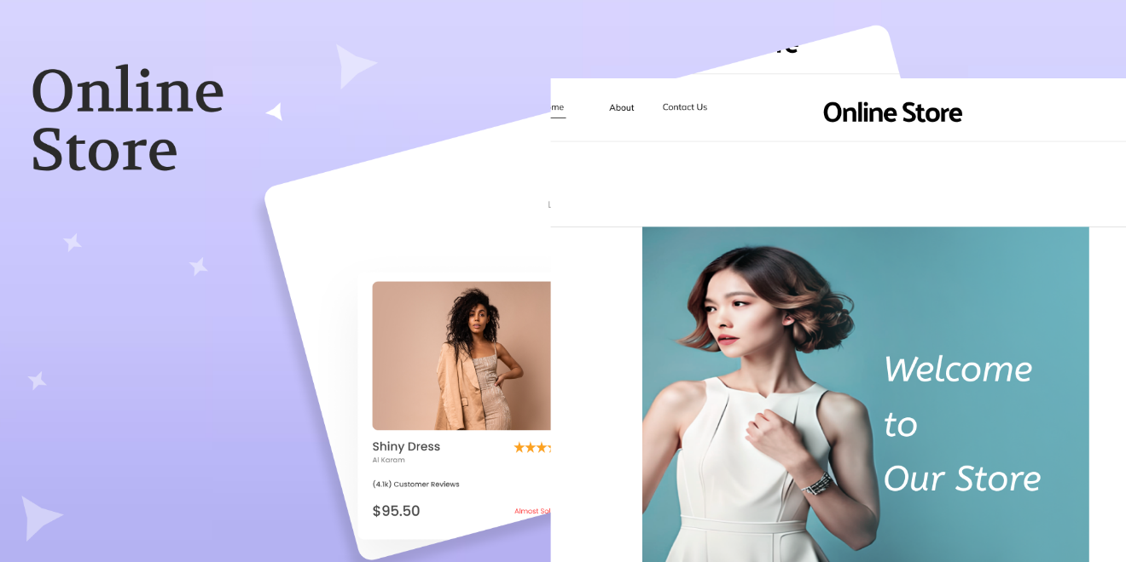

# **UI Design**

**ID:** OCS_UIDesign_01



# **WIREFRAMES DESIGN**

**ID:** OCS_Wireframes_01



# **Class diagram**

**ID:** OCS_ClassDiagram_01

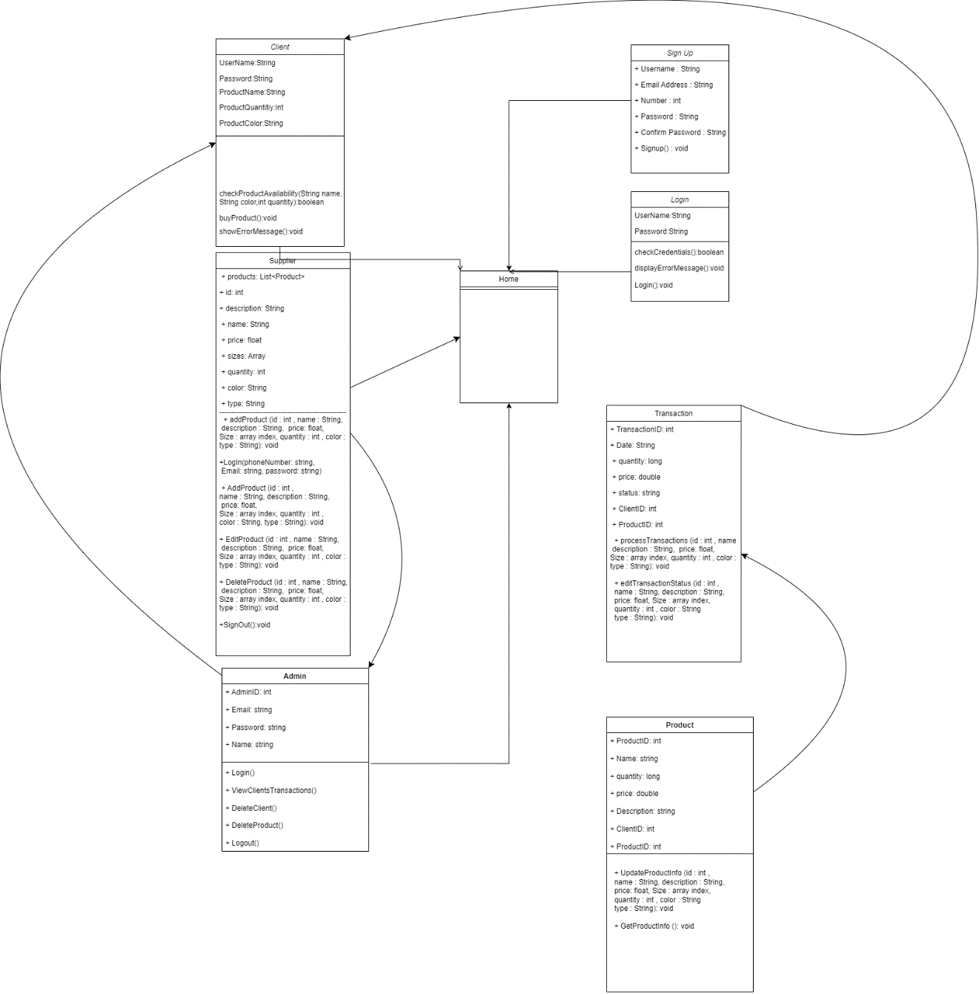

# **Flow charts**

## ID: OCS_Admin_Delete_Client_Account_FlowChart_01

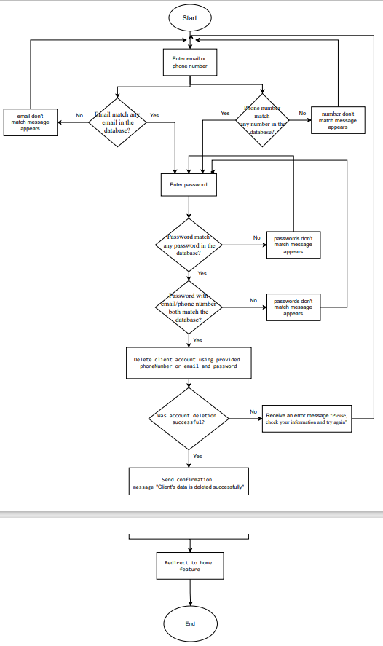

## ID: OCS_Admin_Delete_Product_FlowChart_01

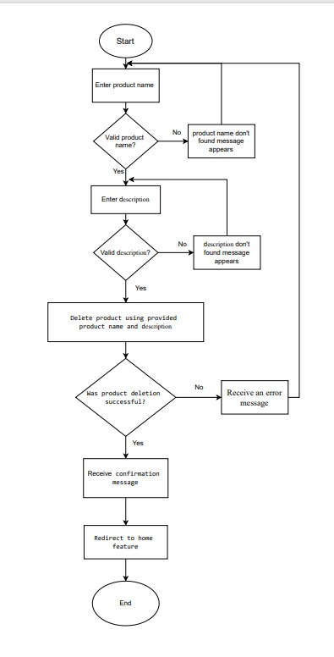

## ID: OCS_Admin_Signout_FlowChart_01

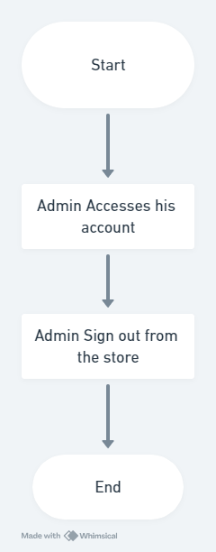

## ID: OCS_Admin_View_Transactions_FlowChart_01

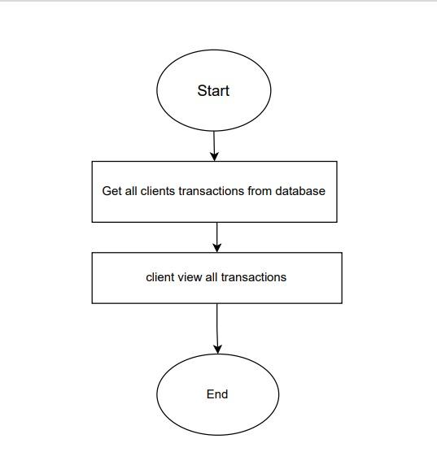

## ID: OCS_Client_Buy_FlowChart_01

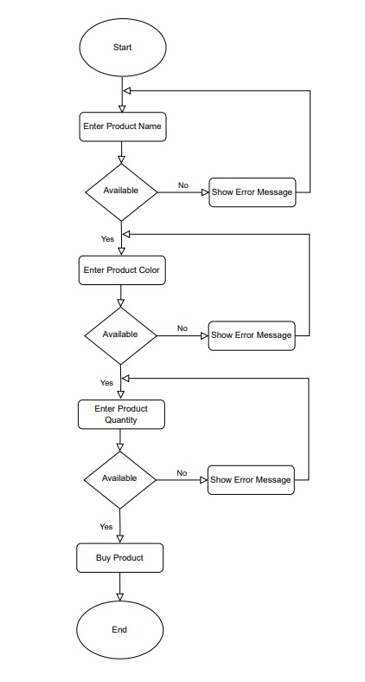

## ID: OCS_Client_Signout_FlowChart_01

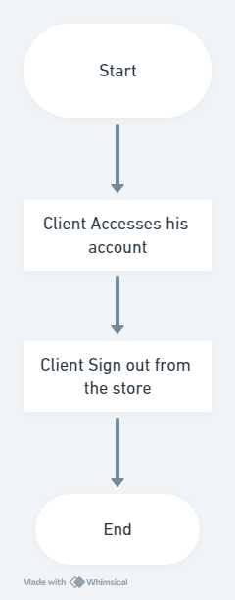

## ID: OCS_Signup_FlowChart_01

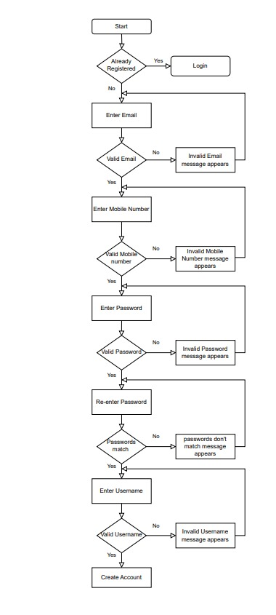

## ID: OCS_Client_Trans_His_FlowChart_01

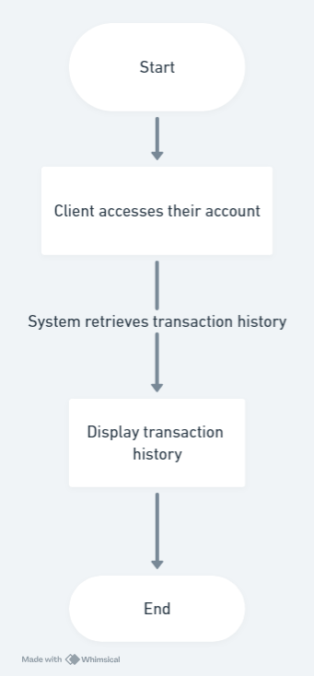

## ID: OCS_Login_FlowChart_01

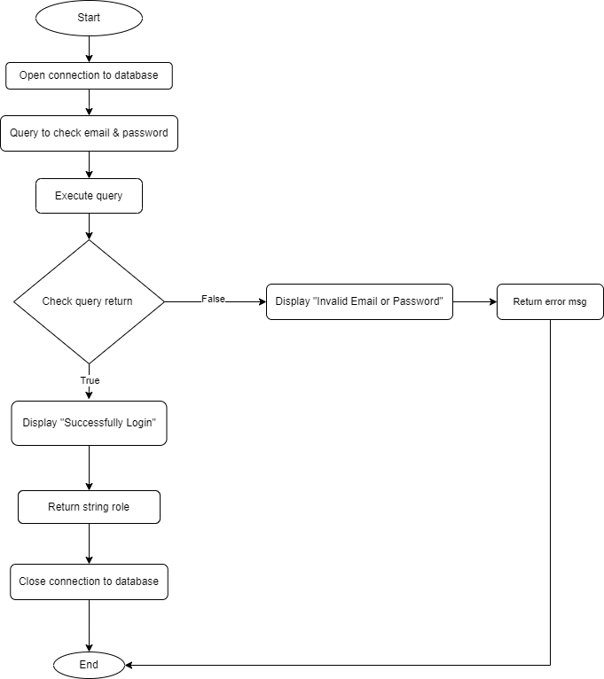

## ID: OCS_Supplier_Edit_FlowChart_01

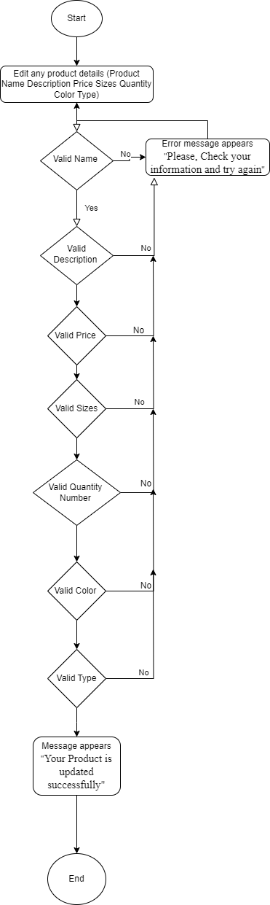

## ID: OCS_Supplier_Sell_FlowChart_01

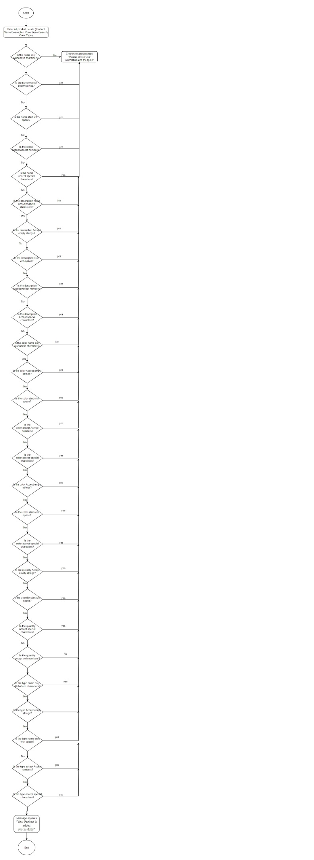

## ID: OCS_Supplier_Signout_FlowChart_01

